**Write a simple program to show inheritance in Scala**

* Inheritance is acquiring the properties of base class. It’s kind of a parent-child relationship where child has its own properties plus the parent’s properties.
* In the below program parent class is Bike where setting the base price of a bike but based on different bikes price may vary.
* So created a Royal Enfield child class where adding the base amount plus the add-on amount.
* Here the child class can access parent class members (fields, methods) by extending it.

Code:

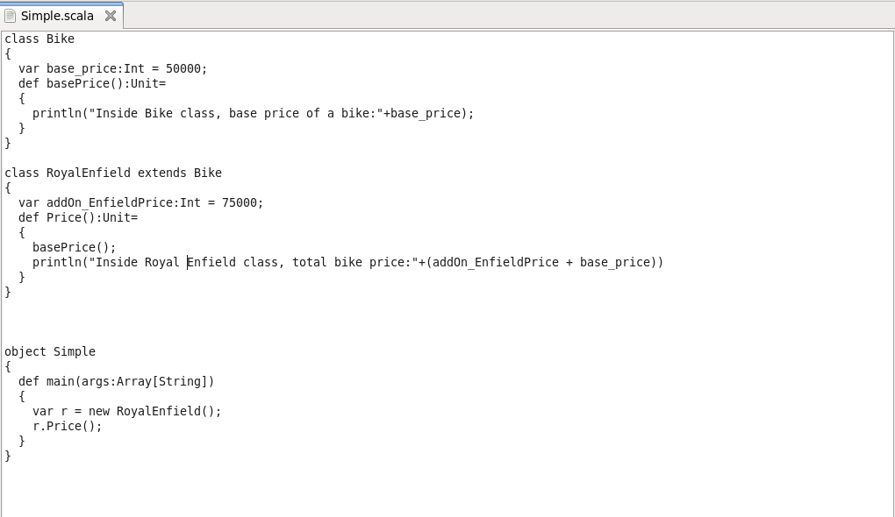

Testing:

